DISTINCT CANINE TUMOR GENOMIC SIGNATURES
UNDERLIE MACROPHAGE POLARIZATION

Introduction
It is well-established that the tumor microenvironment (TME) drives cancer progression. The TME has documented roles in tumor growth and metastasis as well as treatment response and resistance [1–5]. Many new cancer therapies are TME-centric, rather than cancer-cell centric, highlighting the vital importance of improving our understanding of the TME [6]. Another well-documented fact is the marked variability in the TME both between and within tumor types [7–9]. Advancements in single-cell sequencing and transcriptomic techniques have identified immune cell compositions within the TME common across cancer types, and multiple TME sub-types within one tumor type [7–10]. This leads to significant variability in response to immunotherapies, making stratification of patients for appropriate immunotherapy a complex and evolving area of research [11,12].
The TME is shaped by many factors, only some of which are well understood. Tumor histopathology does influence broad patterns. For example, metastatic melanoma, non-small cell lung cancer and triple-negative breast cancer are all commonly treated with checkpoint inhibitors. However, many patients fail to achieve sustained benefits from these therapies, even with newer, combination approaches, due in part to the heterogeneity of the TME [13–16]. Certain mutations in key cancer-related genes have documented impacts on the TME. Loss of the tumor suppressor gene phosphatase and tensin homolog (PTEN) correlates with T cell exclusion and immunotherapy resistance across cancer types [17]. Similarly, gain-of-function mutant p53 has multiple immunosuppressive and pro-metastatic influences on the TME [18]. Patient factors, such as weight and age, have been shown to influence the TME as well, partly due to changes in cellular metabolism and inflammation [19,20]. The metabolic state of the TME changes glucose, amino acids and lipid availability, which affects the crosstalk between immune cells and cancer cells [21,22]. Finally, there is epigenetic regulation of the immune environment of the TME [23,24]. For example, the repressive polycomb-group enzyme enhancer of zeste homolog 2 (EZH2) can methylate and silence promotors of T-cell recruiting chemokines, leading to a “cold” TME, lacking in cytotoxic T-cell infiltration [25]. Cancer therapy itself also applies pressure to the TME resulting in evolution over time [26]. These complex factors combine to make the TME a formidable barrier to effective immunotherapy.
Tumor-associated macrophages (TAMs) are the most abundant immune cell in the TME, comprising a markedly heterogenous group with diverse phenotypes and roles [7,27]. They are being investigated as promising cancer therapeutic targets, biomarkers, and diagnostic imaging markers. TAMs are usually described as having an “M2-like” or immunosuppressive phenotype, although the dichotomous categorization of macrophages into an M1 or M2 phenotype is overly simplistic [28–30]. TAMs can express gene signatures from multiple phenotypes simultaneously, and dozens of phenotypes have been documented in single-cell sequencing studies [7,9,31]. Regardless, TAMs are known to promote tumor progression in multiple ways, including enabling angiogenesis, facilitating tumor cell invasion and metastasis, and enhancing immune avoidance [32,33]. Many TAM-targeted therapies are in early-stage clinical trials in people, and a handful have been explored in dogs [34,35].
Dogs have become a popular model for studying human cancer, due to the similarities of their spontaneously occurring tumors, biology, and environmental exposures [36,37]. In particular, the canine and human immune systems are much more closely aligned than the murine one [38]. When canine clinical trials are incorporated into the pre-clinical drug discovery pathway, there are distinct advantages in cost and time when compared to standard drug discovery [36,37]. There are several examples of FDA-approved cancer drugs that were discovered and approved through parallel efforts of human and veterinary researchers [36].
There is an extensive need for continued work in identifying appropriate TME-based biomarkers for cancer therapy. In this work, we therefore envisioned a novel method of identifying potential biomarkers or therapeutic targets in the TME. Our aim was to correlate macrophage phenotypes after being polarized with tumor-conditioned media (TCM) with mutational and gene-expression data from canine cancer cell lines. We hypothesized that canine cancer cell lines would have varying abilities to polarize primary macrophages as measured by secretory products, irrespective of histology. We also hypothesized that those that have the strongest ability to polarize macrophages would have similar differentially expressed genes (DEGs) that may be useful as biomarkers or therapeutic targets.

Materials and Methods
Cell line maintenance and validation-
All cell lines were maintained in complete growth media composed of Dulbecco’s modified essential medium (DMEM, Gibco, Grand Island, NY) or Roswell Park Memorial Institute media (RPMI, Gibco, Grand Island, NY) medium supplemented with 1× MEM vitamin solution (Corning, Corning, NY), 2 mM L-glutamine (Corning), 1 mM sodium pyruvate (Corning), and 10% heat-inactivated fetal bovine serum (FBS) (Peak Serum, Bradenton, FL) [D10/R10]. All cells were grown in a 37°C humidified atmosphere with 5% CO₂ and serially passaged by trypsinization or density gradient centrifugation as needed. Cell lines were validated to be of canine origin using multispecies multiplex PCR as described and validated as mycoplasma-free [39].
Generation of standardized TCM –
To generate standardized TCM, cell aliquots for adherent cell lines were thawed from liquid nitrogen storage and seeded into a T-150 flask in D10. Cell lines were allowed to grow to 80% confluency or for a minimum of 24 hours if they were already at 80% confluency. They were then trypsinized, and 10⁶ cells were re-seeded into the same T-150. They were allowed to again grow to 80% confluency, at which point the media was removed and 9 mL of fresh D10 was added. 24 hours later, this media was collected as the standardized TCM. The cells were trypsinized and counted. After all adherent cell line TCM was collected, a median cell number at time of TCM harvest was calculated. For the suspension cell lines, an aliquot was similarly seeded into a T-150 in R10. After 48 hours, they were counted, and 10⁶ cells were re-seeded into the same T-150. After 2-4 days, they were counted again, and 50% of the median number of adherent cells at the time of TCM harvest was seeded into the T-150 with 9 mL of D10. After 24 hours, this media was collected as the TCM, and the cells were counted. The median cell count that TCM was harvested from was 10.2 x 10⁶ , ranging from 4.9 x 10⁶ to 20.04 x 10⁶ cells. There was no statistically significant difference in cell count distributions across histology groups (p = 0.26, Kruskal-Wallis rank sum test; see Supplementary Figure 2.1).
Primary macrophage culture –
Canine peripheral blood mononuclear cells were isolated with lymphocyte separation media (Corning) per manufacturer instructions from donors presented as patients to the Flint Animal Cancer Center (FACC) with owner consent and under an existing Colorado State University Clinical Review Board protocol. The WBCs were plated in RPMI with 20% FBS and left to adhere overnight, after which the media with nonadherent cells were discarded. Monocytes were maintained in RPMI 20% with 40 ng/uL macrophage colony-stimulating factor (M-CSF, Peprotech Inc., Cranbury, NJ) for 7 days, with 50% media changes every 2-3 days. For the primary TCM polarization experiment, 3 donors were used, and each donor’s blood was split into 25 wells. After 7 days of differentiation, each well was treated with a different TCM at a ratio of 70% TCM to 30% R10, and two control wells were treated with 70% D10 to 30% R10 for 24 hours. After 24 hours, 3 phosphate buffered saline (PBS, Corning) washes were performed, and 600 uL R10 was added. After another 24 hours, these supernatants were collected for analysis. One control well was used to count the number of macrophages. In parallel, control wells absent of cells but otherwise treated similarly were also analyzed to demonstrate that the PBS washes fully removed all traces of the TCM, verifying that only macrophage supernatants were being measured. Donor details are provided in Supplementary Table 2.1.
Cytokine analysis of cell supernatants –
Concentrations of c–c motif chemokine ligand 2 (CCL2), vascular endothelial growth factor (VEGF), transforming growth factor-beta (TGF-β), tumor necrosis factor-alpha (TNF-α) and CCL3 were measured by commercially available enzyme-linked immunosorbent assay (ELISA) kits. (R&D Systems Inc, products DY1774 (CCL2), DY1603 (VEGF), DY240 (TGF-β), and TNF-α (DY1507); Kingfisher, product DIY1367D (CCL3)). Additionally, a 13-plex canine cytokine/chemokine panel (MILLIPLEX®, MilliporeSigma, Burlington, MA) was used for multiplex analysis following the manufacturer’s protocol. Data acquisition was performed on a Luminex® MagPix system, with quality control and initial data processing completed using Luminex® xPONENT software. Processed data were exported for further statistical analysis in using GraphPad Prism v9** (GraphPad Software, Boston, MA) and R (with R Studio) [40].
Normalization of results/rank ordering –
To use each blood donor as a biological replicate, the absolute values from the ELISAs and MILLIPLEX® were normalized. Because the data had a non-normal distribution, a modified z-score was calculated within each analyte (given by modified z-score = [0.6745(the data point – the median of the dataset)] / the median absolute deviation of the dataset). The modified z-score was then used to create a rank order of cancer cell lines for each analyte, with a high modified z-score meaning a cell line stimulated a high relative amount of that secretory product from macrophages, and a low modified z-score meaning a cell line stimulated a low relative amount of that secretory product.
RNA-sequencing and analysis-
Bulk-RNA sequencing (RNA-seq) of the canine cell lines used in this study was carried out by investigators at the FACC as previously described [41]. We were provided raw read counts, transcripts-per-million (TPM) normalized counts, and remove unwanted variation using control genes (RUVg) adjusted counts. For correlational analyses, we used both the RUVg‐normalized counts and TPM-normalized counts, and computed Spearman’s rank correlations between each gene’s expression and each cytokine’s modified Z‐score. Raw p‐values were then adjusted for multiple testing using the FDRtool R package. To identify genes that were differentially expressed between “high” versus “low” macrophage stimulators, we used DESeq2 on the raw‐count matrix. After filtering out genes with very low counts (< 3 raw counts or detected in fewer than half of the samples under analysis), DESeq2’s internal size‐factor normalization was applied, and the DESeq workflow was used to fit negative‐binomial models. We applied log2-fold-change shrinkage with the ashr method [42]. Genes with absolute values of log₂(fold‐change) $≥$ 1 and a Benjamini–Hochberg (BH)–adjusted p‐value $≤$ 0.05 were called differentially expressed. Finally, we performed pre-ranked gene set enrichment analysis (GSEA) against four Molecular Signatures Database (MsigDB) collections (hallmark (H), curated pathways (C2), gene ontology (C5), oncogenic signatures (C6) and immunologic signatures (C7)) using the R packages msigdbr and clusterProfiler. We considered BH-adjusted p-values ≤ 0.25 as significant.
Validation study –
To independently replicate a selection of our original findings, two cell lines that were high stimulators of VEGF in our original experiment (Nike and Parks) and two cell lines that were low stimulators of VEGF in our original experiment (CLL1390 and 1771) were chosen to generate fresh batches of standardized TCM. Additionally, four new cell lines were chosen from new RNAseq data available from the FACC investigators (personal communications, D. Duval and S. Das) that were either high (Angus and Cindy) or low (SB and Tyler1) in relative expression of MVB12A. The TCM was made as described above. Macrophages were differentiated from 3 new canine donors, treated with the 8 new TCM, and the supernatants were collected and measured for VEGF by ELISA as described above. In order to interrogate exosome cargo, exosome-rich fraction was exposed to 5x RIPA buffer (Thermo-Fisher, # 89900) in equal volume to the total volume of the depleted fraction to lyse the exosomes as has been described [43].
Exosome depletion study –
To assess the effects of exosomes on VEGF stimulation, the top 7 VEGF stimulating cell lines were chosen for further analysis. Fresh aliquots of the harvested TCM were thawed and divided into 3 fractions. One fraction was the normal TCM, one was depleted of exosomes using exosome spin columns per manufacturer’s instructions (Invitrogen, #4484449), and one was an exosome-rich fraction in which the exosomes which were depleted from the TCM were resuspended in an equal volume of DMEM media. Exosome counts per milliliter among each fraction were quantified using tunable resistant pulse sensing (Qnano Gold, Izon) with a nano-pore 150 (Izon) set to ~47 nm stretch and measured against standardized calibration particles (by Eric Palmer) (CPC200, Izon). Macrophages were cultured as described above from 3 new canine donors, with each donor’s blood split between 21 wells. After 7 days of differentiation, one well each was treated with the 21 conditions (7 TCM, each with a normal,
exosome-deplete and exosome-only fraction). Washes, supernatant collection and VEGF measurement were performed as above.
CCL3 knockdown-
Small-interfering RNA (siRNA) were designed against canine CCL3 in conjunction with non-targeting control (NTC) RNA (targeting siRNA sequences: GAA UAU GUG GCC GAU CUG AAG CUG A; CCU UUU CUG GUG UUC CGA AAG AUA AUA CCG; CUU UUC UGG UUU CGA AGA UAA UAC CGG; NTC MISSION® siRNA Universal Negative Control #1, SIC001, Sigma-Aldrich). siRNA-mediated knockdown in DH82 cells was performed by seeding cells at 50,000 per well in a 6 well plate in antibiotic‐free medium 24 hours prior to transfection. Gene‐specific or non‐targeting control siRNAs were added at a titration of concentrations to assess knockdown efficiency. Ultimately 100 nM final concentration siRNA were complexed with HiPerfect transfection reagent (Qiagen, # 301704) in Opti-MEM reduced serum media (Thermo-Fishcer, # 31985088) and added to cultures according to the manufacturer’s protocol. Cells were incubated for 24 hrs, after which media was replaced with D10. Knockdown efficiency was assessed at 24, 48 and 72 hrs post-transfection by western blotting with an anti-CCL3 antibody (Kingfisher, # KP1365D) and by CCL3 ELISA as described above on supernatants from the knockdown (KD), NTC and wildtype (WT) cells (Supplementary Figure 2.2).
CCL3 stimulation-
To assess the effects of CCL3 on TNF-α secretion, macrophages from 3 new canine donors were treated in triplicate with a titration of recombinant canine CCL3 (Kingfisher, #RP0980D) ranging from 0 to 5 ng/uL. After 24 hours of stimulation, supernatants were collected and measured for TNF-α. Due to visual detachment of macrophages at higher levels of CCL3, ELISA results were adjusted with a correction for cell count. Then, the knockdown of CCL3 as described above was performed on DH82 before fresh TCM was collected from WT-DH82, KD-DH82 and NTC-DH82. Macrophages from 3 new canine donors were differentiated as above and then treated for 24 hours with the three TCM conditions in triplicate. Washes, supernatant collection and CCL3 ELISA were performed as above.
Statistical Analysis-
Data were assessed for normality with the Shapiro-Wilk test. Descriptive statistics were used to describe data where applicable (mean ± SEM or median [range]). Graphs were generated and statistical analyses were performed using GraphPad Prism v9** (GraphPad Software, Boston, MA) and R (with R Studio) [40]. Statistical comparisons between groups were performed using unpaired two-tailed Student’s t-tests. Welch’s correction was applied when group variances were unequal. In cases where data were not normally distributed, a non-parametric Mann–Whitney U test was used. A Wilcoxon rank sum test or Kruskal-Wallis rank sum test were used for correlating mutational status or phosphorylation status and cytokine secretion. Linear regression or linear mixed-modeling was used when looking for relationships between variables. Overrepresentation analysis was performed by permutation testing (random seed, 5000 permutations, BH-adjusted p-values).

Results
Classification and correlation of macrophage secretions
In total, the canine MILLIPLEX® measures 13 immunomodulatory cytokines and chemokines, including interferon-gamma (IFN-γ), CCL2, interleukin-8 (IL-8), IL-10, IL-2, IL-6, keratinocyte chemoattractant-like chemokine (KC-like), IL-18, TNFα, IL-7, interferon gamma-induced protein 10 (IP-10), IL-15 and granulocyte-macrophage colony-stimulating factor (GM-CSF). In addition, we performed individual ELISAs to quantify VEGF and TGF-β. Of these 15 analytes, 8 (IL-15, IFN- γ, IL-2, IL-6, IL-7, IP-10, IL-18 and GM-CSF) were below the lower limit of quantification in most samples measured. We therefore elected to exclude them for further quantitative analysis to avoid over-interpretation. Descriptive statistics of the remainder of the analytes are shown in Table 2.1. All conditions stimulated markedly high levels of CCL2 from macrophages, being above the detectable limit on MILLIPLEX® analysis and requiring a 150x dilution on subsequent ELISA to measure. Modified z-scored values for each analyte are shown in Figure 2.1. Raw values from each donor are shown in Supplementary Figure 2.3.
There was a significant impact of inter-donor variability on most cytokine levels except KC-like (p = 0.055) and TGF-β (p = 0.604) (Table 2.2). There was no significant impact of cell number at the time of TCM harvest or histology on any of the analytes, indicating that the results were not driven
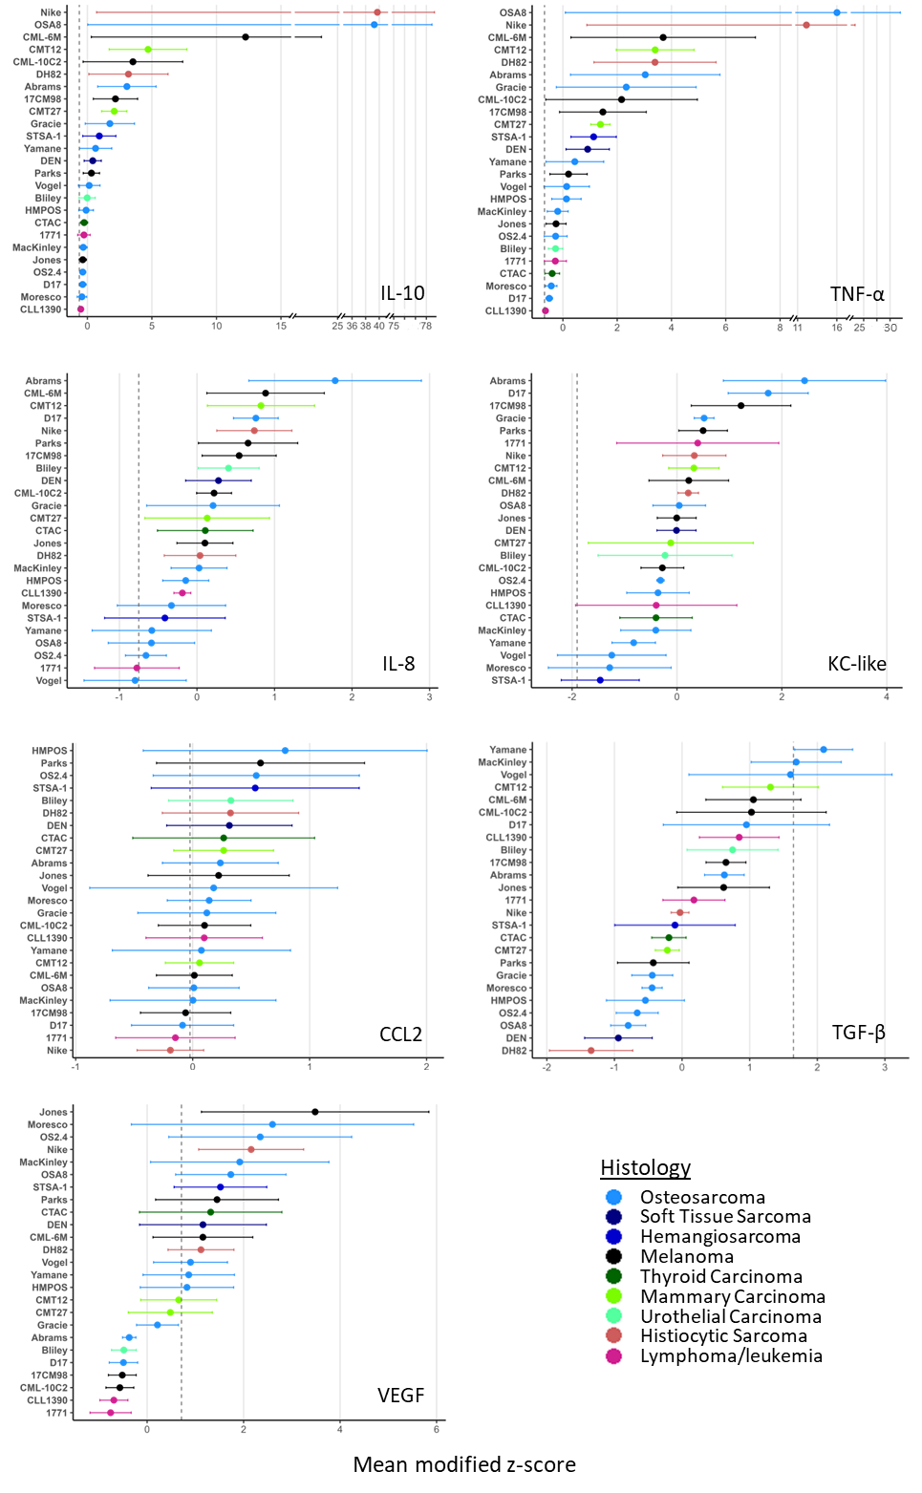
Figure 2.1: Modified z-scores of each analyte. Mean modified z-score for each cytokine, ranked in descending order, color-coded by histology. Vertical dotted line represents the modified z-score of control macrophages (treated with media and M-CSF only) from the same 3 donors. Data are mean +/- SEM; n=3.

Table 2.1. Analytes included for further analysis. Data are expressed as modified z-scores (in median absolute deviation [MAD] units). A modified z-score of +1.0 indicates the measurement lies one MAD above the median, -1.0 indicates one MAD below. Min = minimum, max = maximum.
Analyte | Median | Min | Max | Range
VEGF | 0.8998 | -0.7566 | 3.4840 | 4.2410
IL-8 | 0.1068 | -0.7979 | 1.7820 | 2.5800
KC-like | -0.0092 | -1.4630 | 2.4330 | 3.8950
IL-10 | 0.4153 | -0.5104 | 39.730 | 40.240
CCL2 | 0.1410 | -0.1905 | 0.7910 | 0.9815
TGF-β | 0.1755 | -1.3450 | 2.0940 | 3.4380
TNF-α | 0.4402 | -0.6415 | 16.020 | 16.660

Table 2.2: Donor-to-donor variability in modified z-scores of each cytokine. ICC (intraclass correlation coefficients) represent the fraction of total variance attributable to donor identity and the corresponding p-value from a likelihood-ratio test comparing models with and without donor as a random effect.
Cytokine | ICC | p-value
VEGF | 0.614 | <0.001
IL-8 | 0.209 | <0.001
KC-like | 0.096 | 0.055
IL-10 | 0.115 | 0.028
CCL2 | 0.754 | <0.001
TNF-α | 0.182 | 0.002
TGF-β | 0.020 | 0.604

by differences in cell density during TCM collection or by the histology subtype of the cells (Supplementary Table 2.2 and Supplementary Figure 2.4). Several of the analytes had significant correlations with each other, most strongly IL-10 and TNF-α (Figure 2.2). This would mean, for example, that a macrophage population that was secreting IL-10 at relatively high levels was likely to also be secreting TNF-α at relative high levels. There were no over-represented cell lines or histologies in the top or bottom quartiles based on adjusted p-values from permutation testing. Investigators at the FACC had previously performed whole-exome sequencing on over 30 canine cell lines, providing mutational status for 24 of the cell lines used in this work, as well as classifying phosphorylated protein kinase b (AKT) and extracellular signal-regulated kinase (ERK) as active, constitutive or low [44]. We therefore looked for correlations between our data and mutational and phosphorylation status. Although none of the results remained significant after correction for the false-discovery rate, there were several interesting findings on unadjusted p-value that could warrant follow-up investigations (Supplementary Figure 2.5).
Canine cancer cell lines capable of potent polarization have relevant DEGs and pathways.
Investigators at the FACC had previously performed RNA-seq on 23 of the cell lines used in this work (excepting Vogel [osteosarcoma] and CMT27 [mammary carcinoma]) [41]. Therefore, we performed a Spearman’s rank correlation between the modified z-scores of each cytokine and the available RNA-seq data. Using Spearman correlation of TPM‐normalized expression with VEGF modified Z‐scores, we identified two genes whose expression was strongly associated with VEGF secretion. First, multivesicular body subunit 12A (MVB12A, ρ = 0.817, q = 0.038), a key component of
the endosomal sorting complex required for transport I (ESCRT‐I) that regulates exosome biogenesis (45,46). Second, an unannotated Ensembl ID ENSCAFG00000024217 (ρ = 0.813, q = 0.038), which

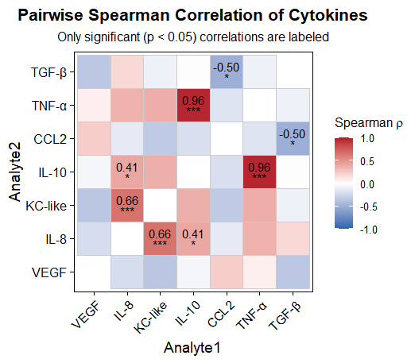
Figure 2.2: Spearman correlation heatmap of cytokine secretion. Each tile is colored by the Spearman ρ value (red = positive correlation, blue = negative correlation; scale bar at right). Only correlations that reached statistical significance (two‐tailed Spearman test, p < 0.05) are annotated.

orthology analysis revealed corresponds to trafficking protein particle complex subunit 5 (TRAPPC5), a subunit of the TRAPP complex also involved in vesicular trafficking [47]. Both findings suggest a potential mechanistic link between vesicle/exosome pathways and VEGF release in these cell lines (Figure 2.3). All results are provided in the link at the bottom of Supplementary Materials: Chapter 2.
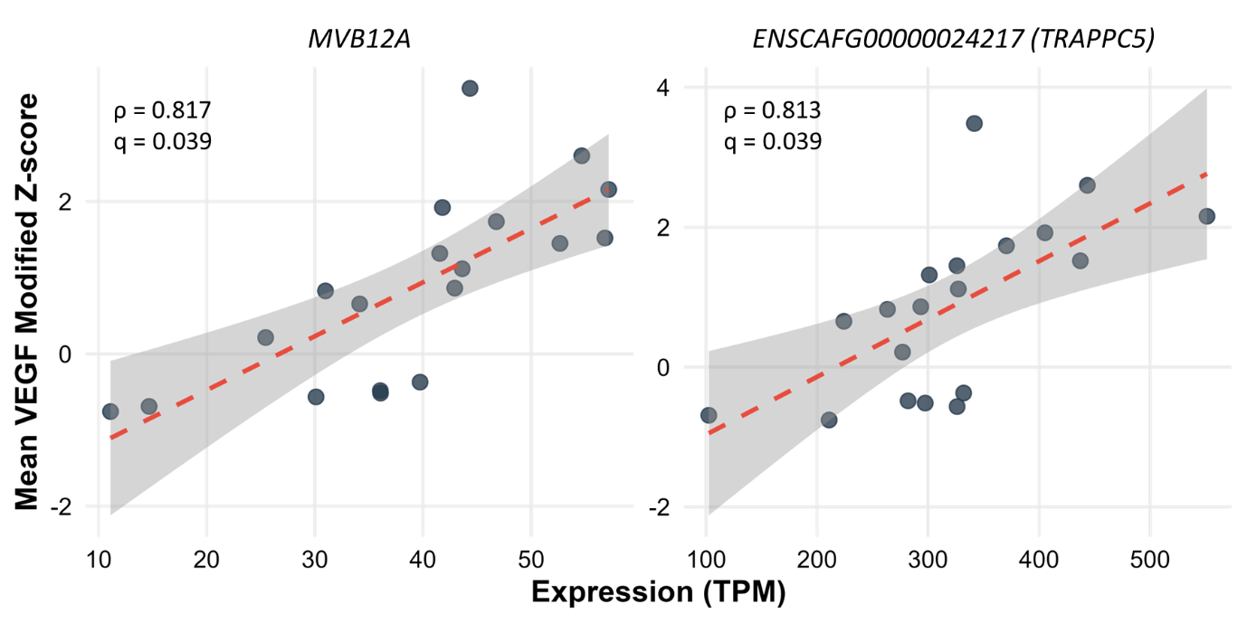
Figure 2.3: Spearman correlation between gene expression and VEGF response. Scatter‐plots showing the relationship between TPM‐normalized RNA-seq expression of MVB12A (left panel) and TRAPPC5 (ENSCAFG00000024217; right panel) versus mean VEGF modified Z-scores. Dashed red lines depict the linear regression trend with 95% confidence bands; annotations show each gene’s Spearman ρ and q-value.

We also performed pairwise differential gene analysis, in which we established “high” and “low” stimulator groups for each analyte between the top and bottom quartiles of the modified z-scores. Analysis showed significant differences between high and low stimulator groups for all analytes (Supplementary Table 2.3). IL-8 and KC-like had a low number of DEGs (2 and 3, respectively); the remainder of the cytokines had between 10 and 60 DEGs between high and low stimulator groups (Figure 2.4, Table 2.3). A positive correlation indicates higher relative secretion from the macrophages (higher modified z-score) with higher gene expression, and a negative correlation indicates lower relative secretion from the macrophages (lower modified z-score) with higher gene expression. Across all high-stimulator cytokine groups, relevant strongly up-regulated DEGs includes markers of alternative (M2) macrophage activation, exosome-mediated macrophage priming, suppression of T-cell activation and pro-inflammatory signaling, enhanced macrophage recruitment, and modulation of cell–cell junctions [48–55]. An additional finding of interest was the unique elevation of RARRES2 in high VEGF-stimulators, a gene that was recently shown to sustain osteosarcoma stemness via TAM interactions [56]. In contrast, some of the most down-regulated DEGs were established tumor suppressors and mediators of nuclear factor-kappa B (NF-κB) driven inflammation [57,58). A full list of DEGs is provided in the link at the bottom of Supplementary Materials: Chapter 2.
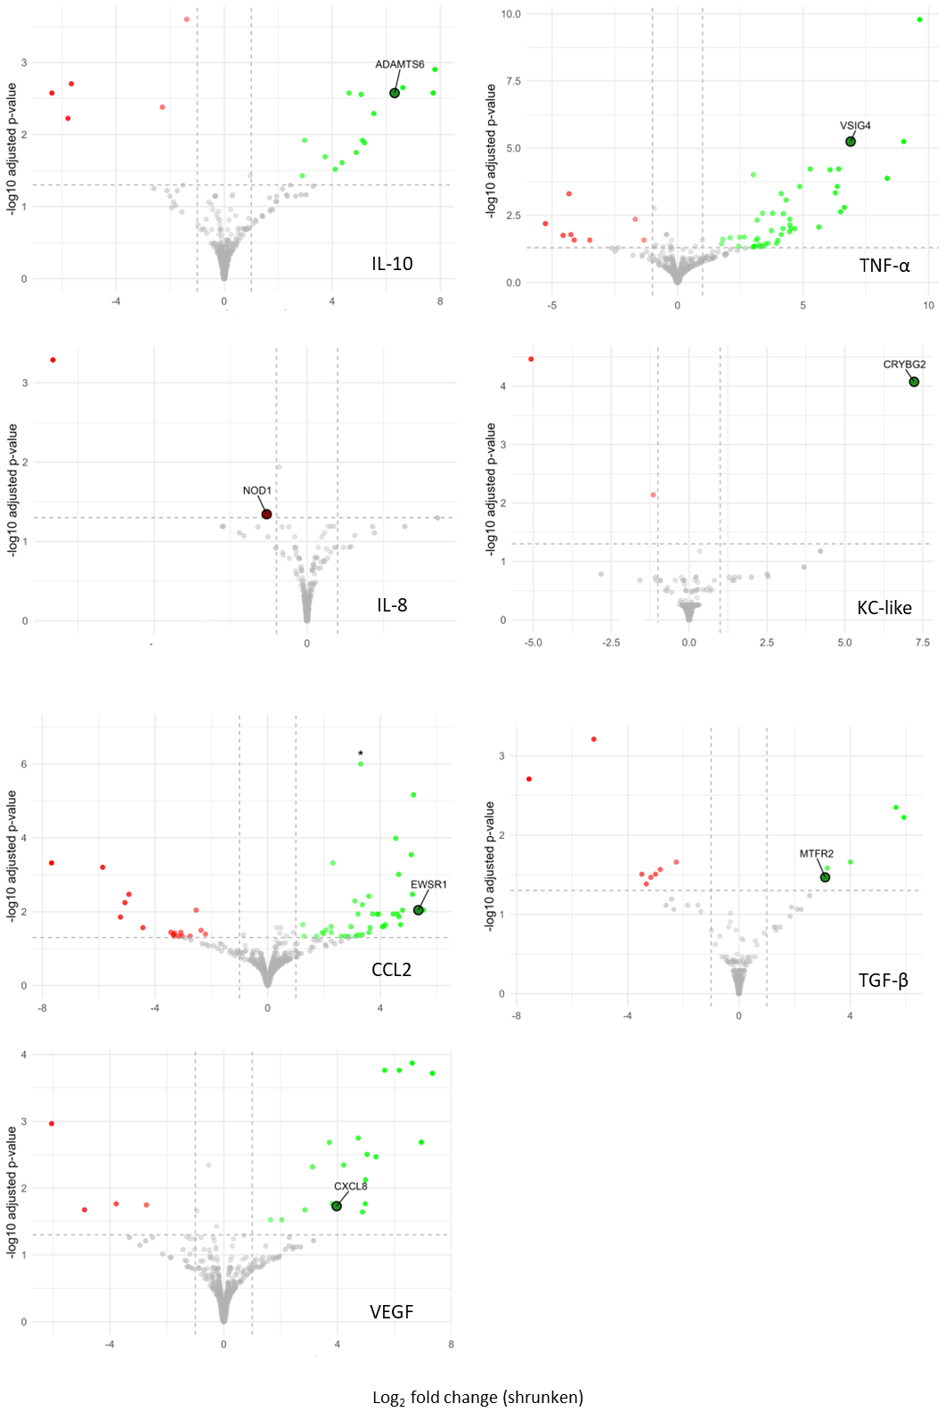
Figure 2.4: Volcano plots of DEGs in pairwise analysis. In each panel, the x-axis shows the shrunken log₂ fold-change and the y-axis shows –log₁₀ of the Benjamini–Hochberg–adjusted p-value. Dashed vertical lines at ±1 log₂FC and a dashed horizontal line at FDR = 0.05 indicate the significance thresholds. Genes with |shrunken log₂FC| ≥ 1 and FDR ≤ 0.05 are colored green (up-regulated) or red (down-regulated); all others are shown in gray. Asterisks mark values that exceed the plotted range (e.g. the CCL2 outlier is capped for display). Some genes of interest are highlighted in associated Table 2.3 (log2FC = log2FoldChange, padj = adjusted p-value).

Table 2.3: Select highlighted differentially expressed genes from Figure 2.4. FC = fold change.
Cytokine | Gene | log2FC | padj | Comment | Citation
IL-10 | ADAMTS6 | 6.308 | 2.65E-03 | Known to dismantle focal adhesions and cell-to-cell junctions | [54]
TNF- α | VSIG4 | 6.894 | 5.68E-06 | Inhibits pro-inflammatory macrophage activation | [51]
IL-8 | NOD1 | -1.321 | 4.53E-02 | Activation results in T-cell mediated anti-tumor immunity | [57]
KC-like | CRYBG2 | 7.223 | 8.45E-05 | Overexpression of similar proteins has been linked to increased cellular motility and invasiveness | [52,53]
CCL2 | EWSR1 | 5.347 | 9.09E-03 | Promotes exosome-mediated macrophage immunosuppressive polarization | [55]
TGF-β | MTFR2 | 3.1 | 3.41E-02 | Upregulation promotes tumor growth, migration and invasion, correlates with immune infiltrates | [48]
VEGF | CXCL8 | 3.967 | 1.86E-02 | TAM-derived CXCL8 promotes tumor migration and invasion | [50]

Although we have highlighted those genes that underscore a relationship between high-stimulators and an
immunosuppressive TME, the full DEG profile is more complex. Several high-stimulator groups also exhibited signatures of pro-inflammatory and M1-associated pathways [59–61]. Elucidating the precise mechanistic links between each cytokine and these divergent gene programs remains an important goal for future work.
We then performed GSEA with the gene lists from the pairwise analysis based on pre-ranked log2foldchange values using MsigDB’s hallmark, C2, C5, C6 and C7 collections. As with the DEGs, high-stimulator groups showed enrichment for pathways both canonically pro- and anti-tumorigenic. For example, high stimulation of TNF-α was enriched for downregulated KRAS signaling, while high stimulation of KC-like was enriched for monocyte chemotaxis. A selection of enriched gene sets is shown in Figure 2.5. All gene sets are provided at the link at the bottom of Supplementary: Chapter 2.
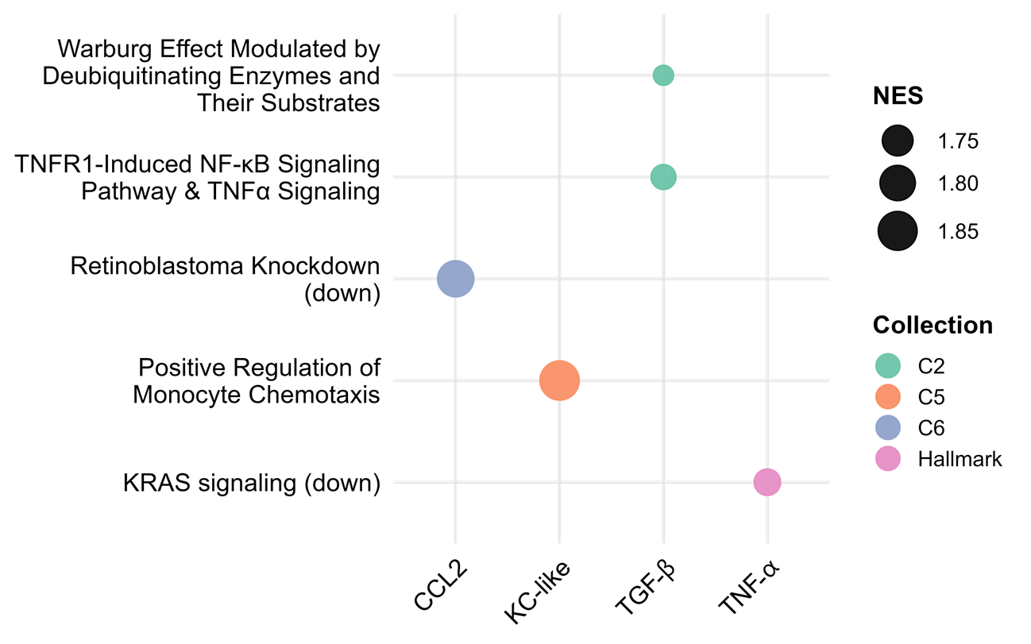
Figure 2.5: Selected GSEA Pathways across cytokines. Each panel shows one of five pathways (y-axis) across four cytokine comparisons (x-axis). Dot color indicates the MsigDB collection (C2, C5, C6, Hallmark) and dot size is proportional to the normalized enrichment score (NES). Larger dots denote stronger enrichment. Pathway names have been edited for clarity.

Cell lines with upregulated MVB12A had the strongest ability to stimulate VEGF from macrophages.
We elected to validate our RNAseq correlation finding regarding the involvement of MVB12A in the stimulation of VEGF from macrophages. Put simply, this finding meant that the cancer cell lines with the highest upregulation of MVB12A were the ones that most strongly stimulated VEGF secretion from the primary macrophages. MVB12A encodes a protein subunit of ESCRT-I, responsible for the sorting of
Cargo into exosomes ([62]. We therefore wanted to determine if exosomes may be in some way connected to the stimulation of VEGF from macrophages. The original TCM from the top 7 VEGF-stimulators were aliquoted into three conditions each: normal TCM, exosome-deplete TCM, and an exosome-only fraction that was resuspended in DMEM. There was significantly higher VEGF measured via ELISA in the macrophages conditioned in the exosome-rich conditions compared to the normal TCM or exosome-depleted conditions (Figure 2.6A). To validate these findings, two cell lines that were high stimulators of VEGF in our original experiment (Nike and Parks) and two cell lines that were low stimulators of VEGF in our original experiment (CLL1390 and 1771) were chosen to generate fresh batches of standardized TCM. Additionally, four new cell lines were chosen from new RNAseq data available from the FACC canine cell line panel (Dawn Duval and Sunetra Das, personal communications) that demonstrate either high (Angus and CIN) or low (SB and Tyler1) relative expression of MVB12A. Seven of the eight cell lines stimulated macrophages as predicted (i.e., high MVB12A stimulated high VEGF). CIN, a hemangiosarcoma cell line which was high in MVB12A with low VEGF stimulation, was the one exception (Figures 2.6B and C). To determine if the exosomes were carrying VEGF themselves or stimulating VEGF through an alternative mechanism, aliquots from the 8 cell lines were again depleted of exosomes, resulting in an aliquot of exosome-depleted TCM and concentrated exosomes. The amount of VEGF in the lysed-exosome fraction was compared to the amount of VEGF in the exosome-depleted fraction. For all MVB12A cell lines tested (including CIN, which did not stimulate relative high VEGF), there was a significantly higher ratio of presumed exosome-associated VEGF to non-exosome associated VEGF (Figure 2.6D).
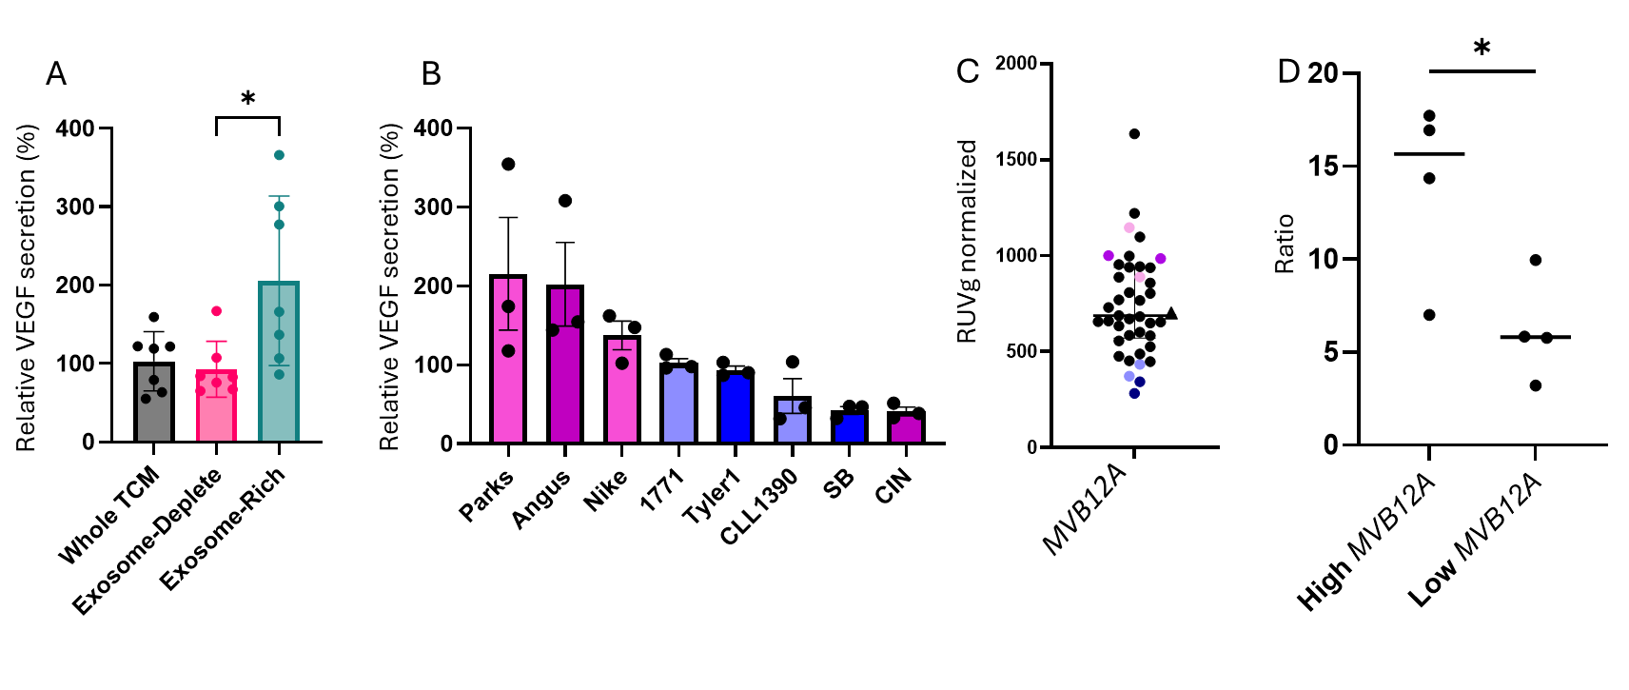
Figure 2.6: Validation of MVB12A’s role in exosome-associated VEGF stimulation. (A) VEGF secretion by macrophages (% of control) after treatment with unmodified tumor-conditioned media (TCM), exosome-deplete TCM, and exosome-rich media, n=3. (B) VEGF secretion (% of control) from TCM derived from high- versus low-MVB12A cell lines, n=3. (C) RUVg-normalized MVB12A expression across all cell lines. For (B) and (C), colors indicate “high” (purple) and “low” (blue) expressors; darker shades denote the discovery set, lighter shades the validation set. (D) Ratio of presumed exosome-associated to free VEGF in the 7 high- vs. low-MVB12A lines from (A) and (B) (p = 0.032 on a Student’s t-test).

Cell lines with CCL3 upregulated stimulated high levels of TNF-α from macrophages.
Finally, in Parks and Angus (two high-stimulator lines), we compared VEGF in non-lysed exosome fractions to exosome-deplete TCM in the same way as above, except without lysing the exosomes with RIPA buffer. The presumed exosome-associated to non-exosome associated VEGF ratio fell sharply (Parks: 17.7x to 5.8x; Angus: 7.0x to 1.3x), suggesting that a substantial fraction of VEGF is packaged inside exosomes rather than merely co-isolated with them. However, further work is needed to verify this finding. There was no dose-response between the number of exosomes and absolute VEGF stimulated in any of the experiments conducted (data not shown).
On inspection of pairwise analysis performed on unfiltered RNAseq data, we noted that two histiocytic sarcoma (HS) cell lines (DH82 and Nike) were driving strong differential expression of CCL3 in high-TNF-α secreting macrophages (adj p-value = 6.39E-11, log2foldchange = 23.14). CCL3, also known as macrophage inflammatory protein 1α, induces the recruitment of myeloid cells and facilitates T-cell responses in the TME [63]. These data were ultimately filtered out due to the requirement that a gene count be present in at least 6 of 12 samples used for pairwise analysis (comprising 6 high-stimulators and 6 low-stimulators for each analyte). However, since these two cell lines are the same histology, we elected to further validate the involvement of CCL3 in the stimulation of TNF-α from macrophages in a mechanism potentially unique to HS. On examination of multiple publicly available datasets, we observed that CCL3 is broadly expressed in canine HS tumors and cell lines. In 11 primary canine tumor samples, 10 had detectable CCL3 mRNA; similarly, 10 of 12 canine HS cell lines were CCL3 positive, one of which was DH82. (Data are available from the NCBI BioProject database under the following accessions: BioProject PRJNA614383, PRJNA821096, and PRJNA1218308). On RNAseq data from an expanded FACC panel comprising 42 cell lines of various histology with bulk-RNAseq data, only 4 were positive for CCL3 mRNA expression. These included 2 of 3 HS cell lines (DH82 and Nike; a third was negative) and two other hematopoietic tumors (BRMCT, mast cell tumor, and CLBL1, B-cell lymphoma) (S. Das and D. Duval, personal communications). Investigators at the FACC also shared unpublished data from 12 canine HS tumors from the FACC tumor biorepository, and 12/12 analyzed were positive for CCL3 (S. Beeson and D. Duval, personal communications). Together, these results indicate that CCL3 expression is common in canine HS and may be unique to hematopoietic tumors.
We first measured CCL3 levels in all the TCM generated. DH82 and Nike secreted the highest amount of CCL3 as expected. Surprisingly, several other cell lines had low levels of secreted CCL3 that were not captured at the transcript level in the RNAseq data (Figure 2.7A). We then replicated our findings with recombinant canine CCL3, showing that CCL3 causes a dose-dependent increase in TNF-α secretion from macrophages. These results were adjusted for relative cell counts as visually more macrophages were detached at higher concentrations of CCL3 (Figure 2.7B). Then, we knocked down CCL3 in DH82 (KD-DH82) cells prior to harvesting fresh TCM, in parallel with fresh TCM from WT DH82 (WT-DH82) and DH82 treated with NTC siRNA (NTC-DH82). We achieved a roughly 50% knockdown, and this resulted in an average 75% reduction in secreted TNF-α in macrophages treated with TCM from KD-DH82 compared to WT-DH82. Macrophages treated with TCM from NTC-DH82 had a non-significant decrease in TNF-α secretion (Supplementary Figure 2.2, Figure 2.7C).

Discussion
The TME remains a significant barrier to therapy and drives resistance and relapse. One complication of immunotherapy is the significant variability of the TME even within tumor type. Therefore, a deeper understanding of the ways in which tumors maintain their individual microenvironments would be useful to guide therapy. In this work we attempted a novel approach to identifying potential biomarkers and therapeutic targets by measuring cancer cell lines’ ability to stimulate immunomodulatory cytokines from primary macrophages. This acts as a simplified proxy for how tumor cells might influence TAMs in vivo, and the same approach could be taken for other elements of the TME as well. This work demonstrated that the ability of the tested canine cancer cell lines to stimulate immunomodulatory cytokines from macrophages varies considerably, and that this variation is not purely a function of cell line histology. Using existing bulk RNA-seq data, we identified several relevant DEGs and pathways that could be leveraged for future investigative work.

.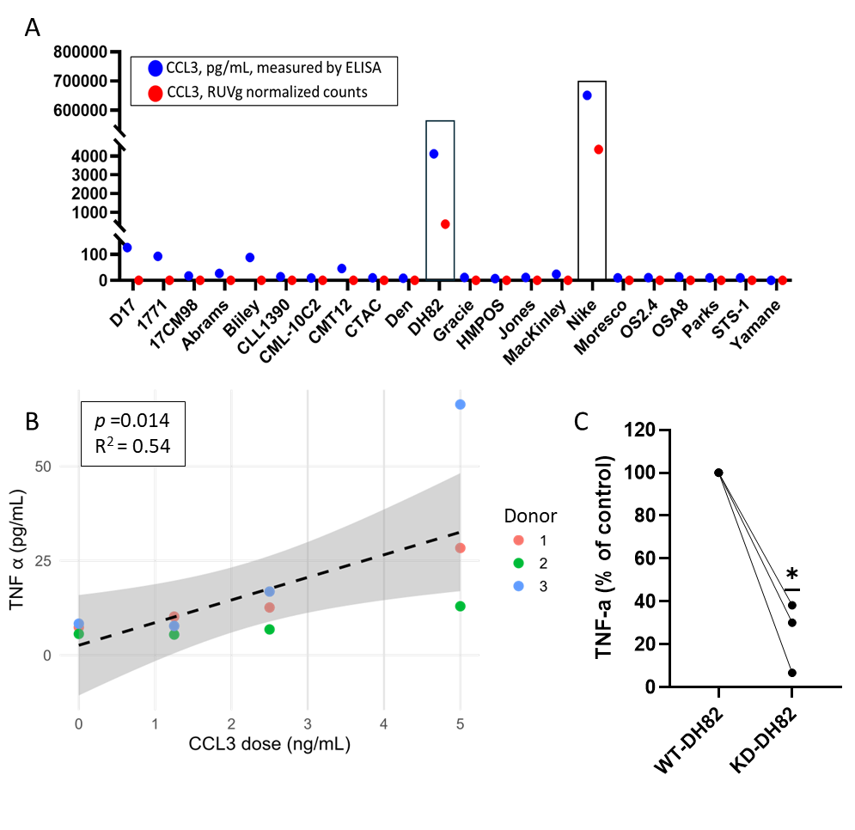
Figure 2.7: CCL3‐induced TNF-α secretion by macrophages. (A) CCL3 protein (blue) and mRNA (red) levels in tumor-conditioned media from multiple cell lines. DH82 and Nike exhibit the highest transcript and secreted protein, whereas some lines show low protein despite undetectable mRNA. (B) Dose-dependent TNF-α secretion by primary macrophages in response to recombinant CCL3 (0–5 ng/mL), modeled using a donor-nested mixed‐effects regression, n=3. (C) Knockdown of CCL3 in DH82 cells (KD-DH82) prior to TCM collection markedly reduces macrophage TNF-α secretion across three independent donors compared to TCM collected from wildtype (WT)-DH82, n=3.

There are various methods to categorize macrophage phenotypes [64]. We elected to work with secretory products as they are crucial signaling elements in many of the immunosuppressive pathways in the TME. In our work, VEGF, TNF-α, IL-10, TGF-β, IL-8, CCL2 and KC-like had significant variability between cancer cell lines and are all known major players in the TME [65–67]. Rather than conceiving of these cytokines as strictly pro- or anti-inflammatory, we took them as markers of an “active” TME, as all of them have conflicting pro- and anti-tumorigenic roles depending on the context. Our analysis primarily focused on cell lines that stimulated high levels of cytokine secretion, yet several analytes showed significant suppression compared to unstimulated macrophages (M0). Specifically, the secretion of TGF-β was significantly lower than M0 baseline levels in almost all cell lines, indicating active cytokine suppression. TGF- β has been linked to decreased proliferation in cell culture and in vivo, so this result may represent a true adaptive mechanism to avoid growth inhibition or an artifact unique to in vitro work that would not be applicable to the TME. Other analytes such as CCL2 showed suppression in a minority of cell lines. The suppressed analyte profiles present potential markers for immune evasion that should be investigated further through functional assays.
VEGF is a pro-angiogenic molecule whose expression is upregulated by hypoxia and supports immunosuppressive phenotypes of several immune cells in the TME. VEGF supports tumor growth not only through its angiogenic effects, but also through mediating vascular permeability and endothelial cell proliferation, which results in abnormal vessels that block immune cell migration [66,68]. TGF-β exhibits contradictory actions in cancer development, but supports EMT, angiogenesis and immune evasion during its later stages. TGF-β can also activate fibroblasts to lay down new extracellular matrix, which creates physical and biochemical barriers for infiltrating cytotoxic lymphocytes [69,70]. TGF-β also sensitizes endothelial cells to VEGF signaling, and in turn VEGF supports the migration of migratory tumor cells following TGF-Β induced EMT [69,71]. CCL2 functions as a powerful monocyte chemokine as it attracts C-C chemokine receptor type 2 positive (CCR2+) monocytes which transform into immunosuppressive TAMs. It also has roles in recruiting myeloid-derived suppressor cells (MDSCs) and regulatory T cells (Tregs), as well as enhancing pro-tumorigenic cancer-associated fibroblasts, therefore being responsible for a large amount of coordinated immunosuppressive efforts in the TME [67].
KC-like and IL-8 showed a moderate positive correlation. These cytokines collaborate to bring immune cells such tumor-associated neutrophils (TANs), TAMs and MDSCs into the TME [72]. There, these immunosuppressive cells produce proteases that break down basement membranes and enable invasion. These cytokines also directly affect endothelial cells and work together with VEGF to promote angiogenesis [65,72,73].
Lastly, IL-10 and TNF-α had the strongest association. The relationship between these cytokines is not unexpected because they function as canonical pro- and anti- inflammatory agents which work together in a continuous feedback loop to regulate each other [74,75]. TNF-α has anti-tumorigenic functions, but it also has established roles in TAM polarization and Treg stabilization [74]. The continuous presence of TNF-α also activates NF-κB signaling pathways within tumor cells and stromal cells to enhance survival and proliferation and stimulate further pro-tumorigenic cytokine production [76]. IL-10, on the other hand, more directly supports an immunosuppressive TME. It suppresses antigen presentation and cytotoxic T-cell activity and induces expression of immune checkpoints on both macrophages and tumor cells [66,77]. It also drives metabolic shift in macrophages towards fatty acid oxidation, reinforcing an immunosuppressive phenotype [78]. The varying ability of the TCM from different cancer cell lines to stimulate these potent immunomodulatory cytokines illustrates the complexity in determining how an individual tumor may maintain its TME.
We validated two findings (MVB12A expression with VEGF secretion and CCL3 expression with TNF-α secretion) with downstream assays. Because MVB12A is a critical protein for loading cargo into exosomes, we performed an exosome-depletion assay. Macrophages incubated with the purified exosome fraction from TCM secreted significantly more VEGF than those treated with whole TCM or exosome-deplete TCM. This suggests an inhibitory factor in the unfractionated TCM that may counteract exosome-driven VEGF stimulation. Potential mechanisms for this inhibitory effect include secretion of soluble receptors that absorb released VEGF, proteases that degrade exosomal ligands, or competitive binding by other cytokines such as TGF-β [79–81]. Regulation of exosome activity could also occur via modulation of the ESCRT-I complex assembly (such as altered phosphorylation of MVB12A itself), changes in intracellular calcium that impact multivesicular body fusion, or by altered expression of tetraspanins that influence exosome docking [62]. Dissecting which of these mechanisms are operating in the TCM would provide valuable insight into the mechanisms governing exosome control by tumor cells. Additionally, while we expected reduction of VEGF secretion in exosome-depleted conditions comparable to exosome-only condition, we also expected to find a decrease relative to the whole-TCM condition. This may not have occurred due to low samples numbers (7 cell lines), and could be rectified by repeating the experiment across all 25 cell lines. Alternatively, it may be a real finding and did not occur because the exosome depletion method used might not deplete soluble factors which help induce VEGF production. The TCM supernatant, even deplete of exosomes, could contain soluble VEGF and other co-factors which could independently stimulate macrophage VEGF production, thus hiding the specific role of exosomes.
We also confirmed that 3 of 4 MVB12A-high cell lines drove high VEGF release in an exosome-dependent manner. The exception was a HSA cell line, which had high MVB12A expression but stimulated low VEGF. Interestingly, another HSA line was among the original low-stimulators of VEGF, which may reflect a histology-specific adaptation (or may reflect chance). Despite documented high levels of secreted VEGF, canine HSA cells have shown insensitivity to VEGF-induced proliferation [82]. It is possible that they would therefore derive little additional benefit from macrophage-secreted VEGF. HSA tumors can also use alternative angiogenic pathways like fibroblast growth factor 2, which could reduce secreted VEGF (83,84). Human angiosarcoma, a comparable malignancy, has documented mutations that result in ligand-independent, constitutive VEGF receptor signaling, again potentially reducing reliance on secreted VEGF (85).
Finally, we explored how exosomes might control VEGF release from macrophages. Possible hypotheses include direct carriage of VEGF protein within exosomes which is then released upon phagocytosis, delivery of upstream regulators (e.g., microRNA-21) that induce VEGF transcription, or broad reprogramming of macrophages toward an M2-like state, indirectly boosting VEGF secretion (86,87). Although lysis of the exosome fraction led to significantly higher measured VEGF (consistent with cargo release), we cannot fully exclude co-isolation of VEGF bound to contaminating proteins. Future studies should employ size-exclusion chromatography or immunoaffinity capture to purify exosomes prior to lysis or perform miRNA-seq / proteomic profiling on vesicle contents to help narrow down the potential mechanism. An additional significant Spearman correlation emerged for high TRAPPC5 expression with high VEGF secretion. TRAPPC5 is a key subunit of the TRAPP complex involved in ER-to-Golgi vesicular trafficking [47]. This raises the possibility that general vesicle-transport machinery, and not just ESCRT-mediated exosome release, could regulate the delivery of macrophage-stimulating factors, and warrants investigation of TRAPPC5’s role in VEGF stimulation.
Histiocytic sarcoma (HS) is a rare malignancy in people that occurs somewhat more frequently in dogs, but carries grave prognosis in both species. There is a distinct need for better therapies for this disease [88,89]. We demonstrated that two canine HS cell lines with CCL3 upregulated stimulated significant TNF-α secretion from macrophages. We also found that CCL3 expression, while common in canine HS, does not appear commonly in non-hematopoietic histologies. It is unclear if TNF-α secretion from macrophages is an anti-tumorigenic benefit that may be overshadowed in the massively immunosuppressive TME, or if TNF-α may be acting in its pro-tumorigenic roles. The mechanism by which upregulated CCL3 drives TNF-a production is unknown. The most straightforward explanation is that secreted CCL3 is directly binding its receptors CCR1/CCR5 on macrophages, triggering downstream mitogen-activated kinase (MAP-K) or NF-κB signaling, which upregulates TNF-α gene transcription [90–92]. Alternatively, CCL3 could stimulate the release of an unknown intermediary cytokine such as IL-1β, which in turn stimulates TNF- α [93]. CCL3 is commonly recognized as a strong chemoattractant for myeloid cells and enhancer of T cell responses, but chronic TNF-α stimulation can paradoxically drive chronic inflammation and lead to immune exhaustion [63,75]. It is possible that disrupting the CCL3-signaling axis, or modulating downstream TNF-α, could improve anti-tumor immunity. Therapies that increase CCL3 at the site of tumors are already being investigated to improve T cell responses and checkpoint inhibitor response [63]. Further work is needed to better understand if tumors high in CCL3 are impacted by CCL3 knockout, and if IL-10 and/or TNF-α modulation impacts the progression of these tumors differently from tumors low in CCL3 expression.
The previous attempts at TME subtyping using single-cell RNA-seq have documented multiple TAM states present in human tumors [7,9,94]. Our method tracks functional secretory outputs following TCM exposure to provide a different phenotypic measurement of tumor-cell signals. The method of measuring active cytokine release from macrophages complements static gene expression analysis. The combination of secretory profiling with transcriptomic subtyping would enhance immunotherapy patient stratification by evaluating both molecular and functional aspects of TAM heterogeneity.
The main limitation in this study is that the in vitro system based on TCM and monocyte-derived macrophage cultures does not match the biological complexity of TAMs that exist in vivo. The TME has evolving metabolic, spatial and temporal heterogeneity, in which macrophages interact with stromal cells, other immune cells and cancer cells. Additionally, although dogs are often an optimal model for human cancer, there are still species differences in cytokine receptor affinities and signaling pathways that could limit translation to people [95]. Another limitation was that the Milliplex bead-based assay and individual ELISAs have differing sensitivities and dynamic ranges, and so comparison of absolute values of different analytes in this work is not recommended. Additionally, the analysis of low-abundance analytes could have been performed using raw or background-subtracted median-fluorescence intensity (MFI) values instead of absolute concentrations. However, because the manufacturer does not validate interpretation of MFI values below the lower limit of quantification, and due to the high rate of non-detects across the samples, we chose a more conservative approach. Future studies with higher-sensitivity assays or pre-enrichment strategies may allow meaningful interpretation of these cytokines. Our study evaluated the relationship between cytokine mRNA expression from bulk RNA-seq data and macrophage polarization results, but we did not establish direct connections between TCM cytokine secretion levels and macrophage polarization states. The measurement of secreted cytokines may not always match mRNA levels because post-transcriptional regulation and vesicular storage mechanisms affect protein abundance. This is demonstrated by our observation of CCL3 protein secretion despite minimal transcript levels in some cell lines. Future research combining proteomic TCM analysis with macrophage phenotyping would establish better connections between tumor-secreted factors and macrophage polarization outcomes. Finally, the current sample size of 25 cell lines together with a small number of donor specimens enables proof-of-concept validation, but future studies are needed to truly understand the diversity amongst cancer patients, as evidenced by our analysis of inter-donor variability.
The National Cancer Institute-MATCH (Molecular Analysis for Therapy Choice) trial (NCT02465060), launched in 2015, aimed to assign patients to appropriate targeted therapies based on molecular profiling in a tumor agnostic fashion. This study achieved its signal-seeking goal, meaning that 25.9% of the treatment arms achieved the predetermined goal of an objective response rate of at least 16% [96]. A follow-up study involving matched immunotherapies is planned [97]. Future research involving NCI-MATCH-style prospective studies could analyze biomarkers such as MVB12A and CCL3 expression levels to determine how patients respond differently to anti-VEGF treatment, exosome-targeting therapies and cytokine modulation. In conclusion, the combination of macrophage phenotypic profiling after exposure to TCM with genomic correlation studies demonstrates promise for TME biomarker discovery. We have shown that canine cancer cell lines have varying abilities to polarize primary macrophages as measured by secretory products irrespective of histology. Those that have the strongest ability to polarize macrophages have similar DEGs that may be useful as biomarkers or therapeutic targets. Further work investigating more of the DEGs and pathways, as well as validating the findings in murine and eventually canine models should be undertaken.

